**Design Report Content and Requirements**

Your report **MUST** follow closely the format outlined in “Case Studies” in Chapter 18 and Example 7-2.

**Format:**

1. The first page of your report is a title page along with a brief introduction to the report.
2. The second page of your report must be the drawing generated by a CAD program with all dimensions shown (a 2-D view similar to that shown on page 942) with dimensions in inches. All dimensions and radius values need to be shown. Tolerances do not need to be specified.
3. The third, fourth, and fifth pages (six maximum) **must** have:
   * a sketch of the shaft labeling analysis points (use the one I gave you),
   * the assigned material properties
   * a table summarizing the moment and torque at analysis points I, J, K, …
   * a table summarizing all the selected diameters ( i.e. D1, D2, …)
   * a table summarizing all safety factors at points I, J, K, …
   * a table of computed bearing reaction forces and C10 loads and type (ball, roller, etc.)
   * A table of the gear and shaft key material, and dimensions (must be a square key).
4. The following pages document how you got those values. **I don’t want to see any iterations on selecting the dimensions, just the calculations for the selected dimensions**.
5. Show computed values **ALL** along the way (so I can more easily see where a mistake is). I must see values for Se, KT, KTS, Kf, Kfs, σa, σm, etc.
6. Show all calculations for point I, then point J, and so on **in that order**. After the last point then show the bearing calculations and lastly the key length calculations.
7. Have an appendix that has screen shots of the selected bearings and retaining clips.
8. Submit your report as a single pdf file.

**More Requirements:**

1. Your report will document all the details of how you computed safety factors, such that someone not in the class could see clearly how you did you calculations. Use Matlab, MathCad or SMath to do your calculations with ***many comments*** to describe what is being done. **Python, Fortran, C++, and other scripts or languages will NOT be accepted**.
2. The gear design is already done. Cite the book for the gear design and just include the resulting gearbox layout and design parameters (e.g. forces, torques, etc.) in your report. There is a small amount of truncation error in the values in Chapter 18. Please use the following design values:

d2 = d4 = 2.667 in, d3 = d5 = 12.0 in, ω2 = 1750 rpm

W23t = 540 lbf, W45t = 2431 lbf, ω5 = 86.42 rpm

W23r = 197 lbf, W45r = 885 lbf, T2 = 720 in-lbf, T5 = 14,586 in-lbf

1. **Triple check that computed reaction forces, moments and torques are correct**. If they are wrong, your design is almost all wrong. The torque is zero from the middle of each gear to the free end. Look at Example 7-2, page 367 for finding moments about the y and z axes and combining them.
2. You **MUST** cite where you got each equation (see Example 7-2)
3. You **MUST** cite where and how you got stress concentration factors, strengths, and other values (see Example 7-2).
4. You **MUST** use Table 7-1 for Kt and Kts for **ALL** stress concentration factors. Do **NOT** revise these factors based on the bearing or retaining ring you selected (this makes it easier for you and for me to grade). Use sharp fillets for bearing shoulders and well-rounded fillets for all other shoulders. You may assume end-mill keyseats are located 0.25” from each edge of the gear. Don’t use a sled runner keyseat. To simplify grading, **compute stresses at retaining ring grooves using the nominal shaft diameter at that location** instead of the smaller groove diameter. The radius values for computing *Kf* and *Kfs* are also obtained using this table.

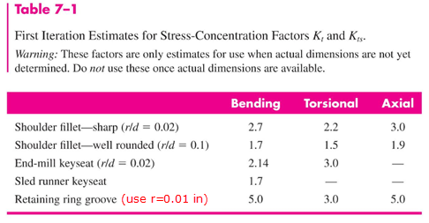

1. Compute safety factors against fatigue (use Modified Goodman) **AND** **yielding** at each critical location. The design goal is *n*=1.5 for fatigue and/or yield (one will control and the other safety factor will be higher). At bearing locations your minimum safety factor may be somewhat greater than 1.5 to accommodate an acceptable bearing. Note that at a given shaft diameter you may compute stresses at up to three points. The location with the highest stress will produce the minimum safety factor and at other locations with the same diameter, the safety factor can be bigger than 1.5.
2. The objective is to reduce the diameter of the shaft at all points as much as reasonably possible.
3. Your report is not a just a list of equations. There must be descriptions of what you are doing and comments describing how you are doing it (similar to Example 7-2).
4. You will need to specify bearings and retaining rings (clips). Start searching for these on Globalspec.com. When you find an item, record the Manufacturer’s name, part number, and important critical dimensions and loads. Do this by using a screen capture to show a page from the manufacturers specifications and an image of the bearing or clip. You **must** show an image of the item. **You cannot select a bearing that just lists a range of sizes and loads** (figure on the right is NOT sufficient).

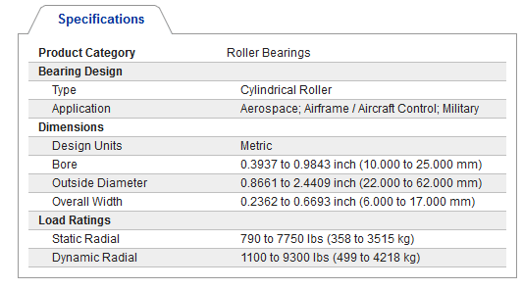

1. The diameter of bearing or gear shoulder is typically 1.15 to 1.2 times the smaller diameter (this matches well with the data in Table 11-2). As a minimum, use a factor of 1.1. In the figure below for the output shaft, make , , and . Note that this often will drive your safety factors to be >1.5. Also note that if safety factors are greater than 1.5, you can allow *D*4=*D*5 (Kt=Kts=1 at point N) or *D*6=*D*7 (Kt=Kts=1 at point Q) because there would be no step change in diameter.

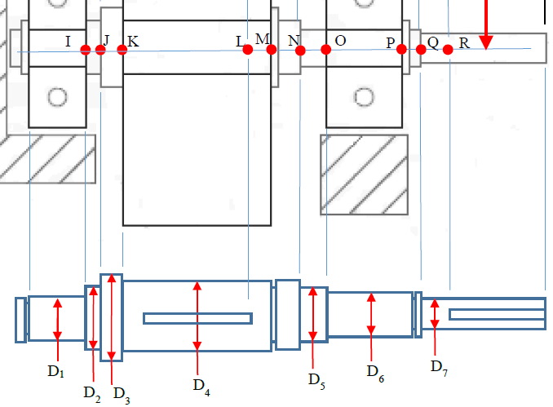

1. Find acceptable bearings early on. Your text does NOT have a good selection. There are more bearings available in metric sizes than in customary units. For higher loads, shift from ball bearings to roller or tapered roller bearings. For Weibull parameters use the values in Table 11-6 on page 601 of your text. Manufacturer 1 is for tapered roller bearings and 2 is for radial ball and roller bearings. The bearings you select will likely have a different width than what was called out in the initial gear box layout. For bearings use af=1 and RD=0.99 for each bearing. If you select a tapered roller bearings, you **must** include induced thrust calculations and Eq. 11-16 or 11-17.

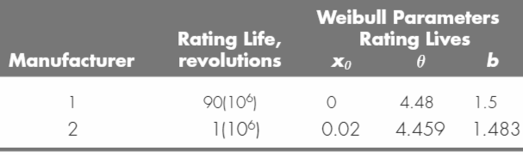

1. Do **NOT** revise the shaft dimensions and computed moments based on the selected bearing widths (this makes it easier for me to grade and less work for you).
2. Your design must be able to be assembled (e.g. you must be able to slide the gear and bearings onto the shaft).
3. **Watch units**. In Eq. 6-19, Sut must be in units of ksi. In Eq. 11-6, if rotations are calculated with MathCad units, they will be used internally as radians and not revolutions.
4. For fatigue calculations, the ka term should use the machined surface parameters and the kb term needs to be recalculated for each diameter:



or you might use the following function to get Se:

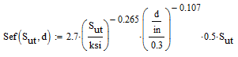

1. Do **NOT** get q’s from Fig. 6-20 and 6-21. Instead make functions for calculating Kf and Kfs: The value r represents the radius of the notch or groove, **not the radius of the shaft**.

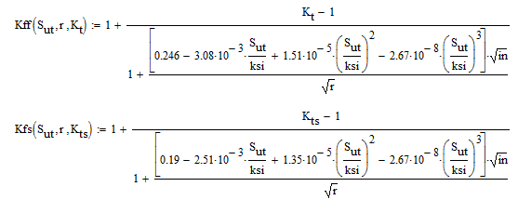

1. For computing the safety factor on yield, use the simpler (and more conservative) formula below. Note that if the alternating stress is zero, the safety factor for fatigue failure is infinite.



1. **Do NOT use Eq. 7-8** to size your diameters. It is used in Example 7-2 for initial sizing but because of other constraints, you will be forced to use a different diameter. Simply apply guess values for all of the needed diameters at the beginning of your MathCad or SMath file. Next compute stresses using Eq. 7-5 and 7-6 and then compute the safety factors using Eq. 6-46 and 7-16 at all analysis points. Next revise the initial guess diameters until an acceptable design is obtained.
2. You need to select the lengths of the keys for the gear and the shaft outside the case. Use a **square key** selected from Table 7-6. **Use a safety factor of 1.5 and assume the key material is 1006 HR steel with Sy=24 ksi.** If you find the key length for the gear exceeds1.75-inch, you can shift to a higher strength key material (just be sure to note that in your report).

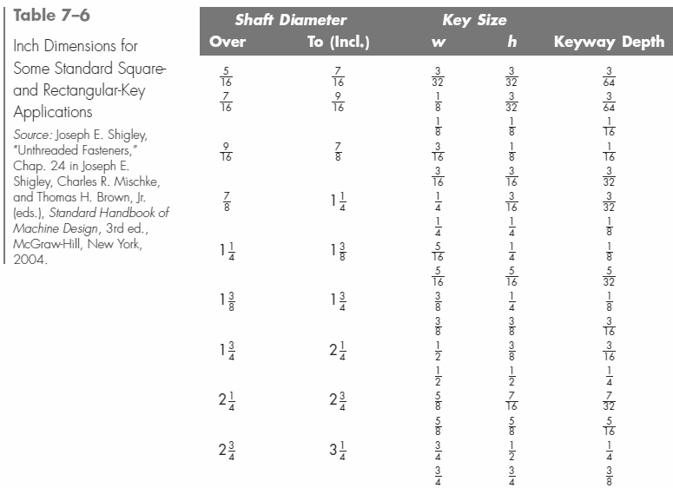

Here is another table that covers larger diameters:

|  |  |  |  |  |
| --- | --- | --- | --- | --- |
| Shaft Diameter | | Key Size | | Keyway |
| Over | To (Incl.) | w | h | Depth |
| 3-1/4 | 3-3/4 | 7/8 | 7/8 | 7/16 |
| 3-3/4 | 4-1/2 | 1 | 1 | 1/2 |
| 4-1/2 | 5-1/2 | 1-1/4 | 1-1/4 | 5/8 |
| 5-1/2 | 6-1/2 | 1-1/2 | 1-1/2 | 3/4 |